keywords

Home
Primary Keyword 21%
- Automobile Exporter in India
Secondary Keywords
- Vehicle Exporter in India
- Two Wheeler Exporter in India
- Three Wheeler Exporter in India
- Four Wheeler Exporter in India
- Automotive Export Company India
- Wholesale Vehicle Exporter India

About Us 20
Primary Keyword
- Bhavana International
Secondary Keywords
- Automobile Export Company India
- Indian Vehicle Export Company
- Automotive Exporter India
- Global Automotive Supplier
- B2B Automobile Exporter

Products
Primary Keyword
- Automotive Products Exporter India
Secondary Keywords
- Two Wheeler Exporter India
- Three Wheeler Exporter India
- Four Wheeler Exporter India
- OEM Spare Parts Exporter India
- Auto Accessories Exporter India
- Tyre & Wheel Exporter India
- Vehicle Spare Parts Supplier India

final home page
Primary Keyword
- Automobile Exporter in India
Secondary Keywords
- Vehicle Exporter in India
- Two Wheeler Exporter in India
- Three Wheeler Exporter in India
- Four Wheeler Exporter in India
- Automotive Export Company India
- Wholesale Vehicle Exporter India

Meta Title

Automobile Exporter in India | Bhavana International

Meta Description

Looking for a trusted Automobile Exporter in India? Bhavana International supplies quality vehicles, OEM spare parts, and automotive products worldwide.

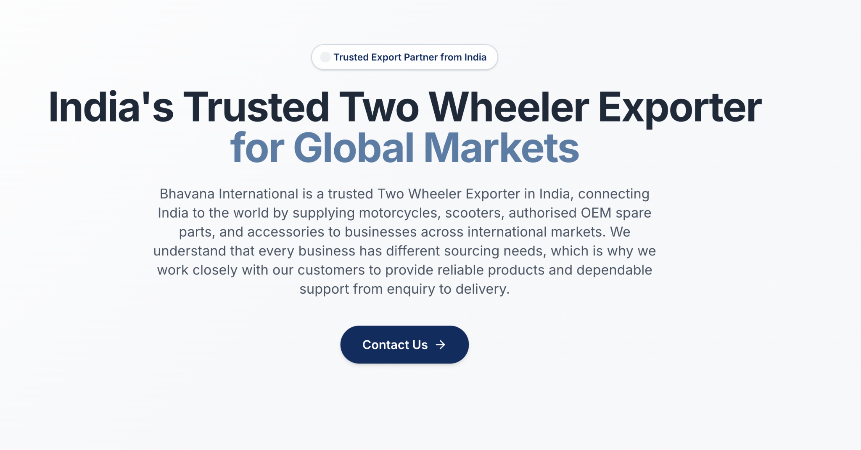
Badge
Trusted Vehicle Export Partner from India

India's Trusted Automobile Exporter
Description
Bhavana International is a trusted Automobile Exporter in India, supplying quality vehicles, OEM spare parts, tyres, wheels, and automotive accessories to businesses worldwide. From your first enquiry to final delivery, we provide reliable support and clear communication to make sourcing from India simple and hassle-free.

Primary CTA: Request a Quote
Secondary CTA: Explore Products



Trusted Export Partner
Built on quality, reliability & transparency
Automotive Product Range
Vehicles, spare parts & accessories
Worldwide Distribution
Supporting importers across global markets
Reliable Customer Support
Dedicated assistance at every stage

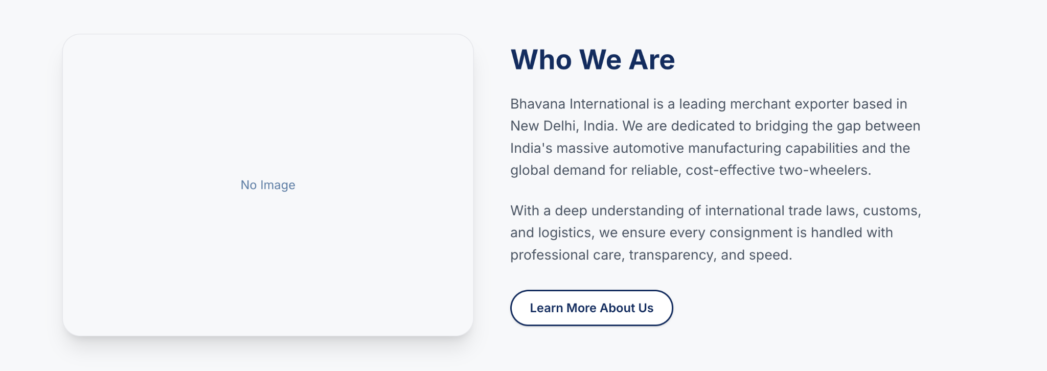

Your Trusted Export Partner
Choosing the right export partner is about more than just products. It's about working with a team you can trust. At Bhavana International, we help businesses source quality vehicles and automotive products from India with reliable support and clear communication.
As a trusted Automobile Exporter in India, we work with importers, distributors, and dealers to make the export process simple and reliable. From enquiry to delivery, every order is handled with care and attention.

Button: Explore Our Products

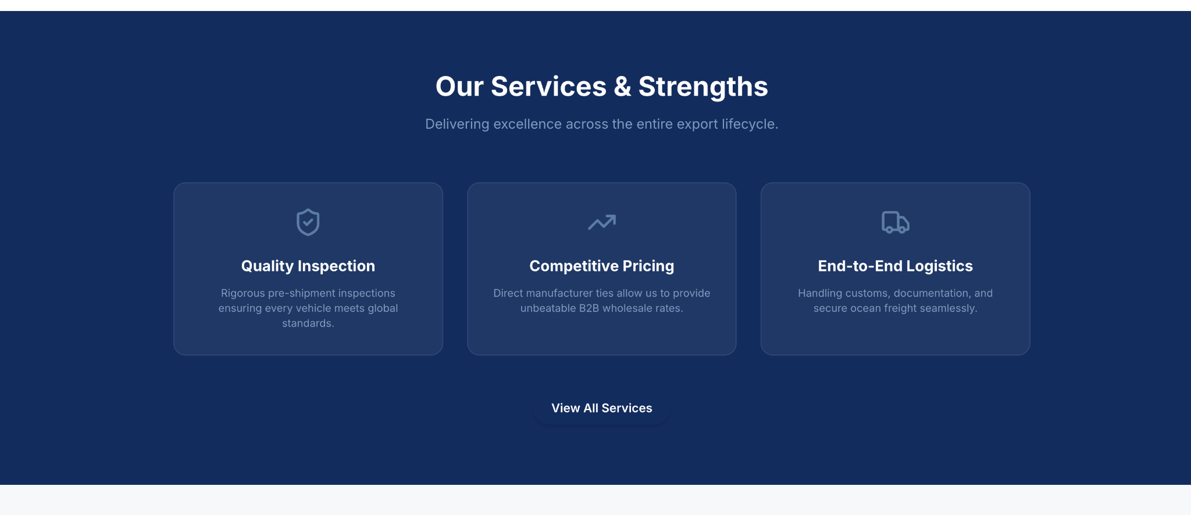

H2

Why Choose Bhavana International
Supporting text
Quality Assured Products
Before your order is shipped, we carefully inspect every vehicle and automotive part to make sure everything is in place.

Reliable Product Sourcing
Products sourced to match your business needs and market demand.

Seamless Export Process
From documentation to delivery, we ensure a smooth export experience.

Dedicated Customer Support
Responsive support and clear communication at every stage.

CTA: Talk to Our Team

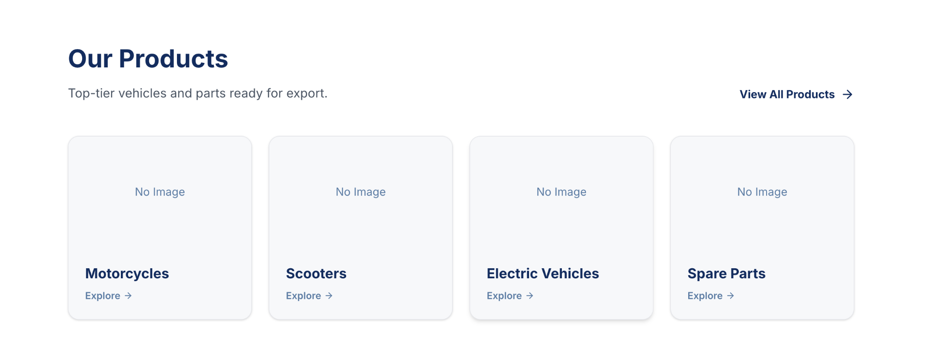

What We Export
Supporting Text
As a trusted Wholesale Vehicle Exporter India, we provide quality vehicles and automotive products with straightforward service and punctual shipments you can count on.
Vehicles
Two wheelers, three wheelers, and four wheelers for global markets.

OEM Spare Parts
Genuine OEM parts built for quality and long-lasting performance.

Tyres & Wheels
Reliable tyres and wheels for every vehicle category.

Automotive Accessories
Quality accessories designed for functionality and style.

Button
View All Products



Exporting Leading automobiles Brands
Add logos of the vehicle companies and make them in moving or rotation
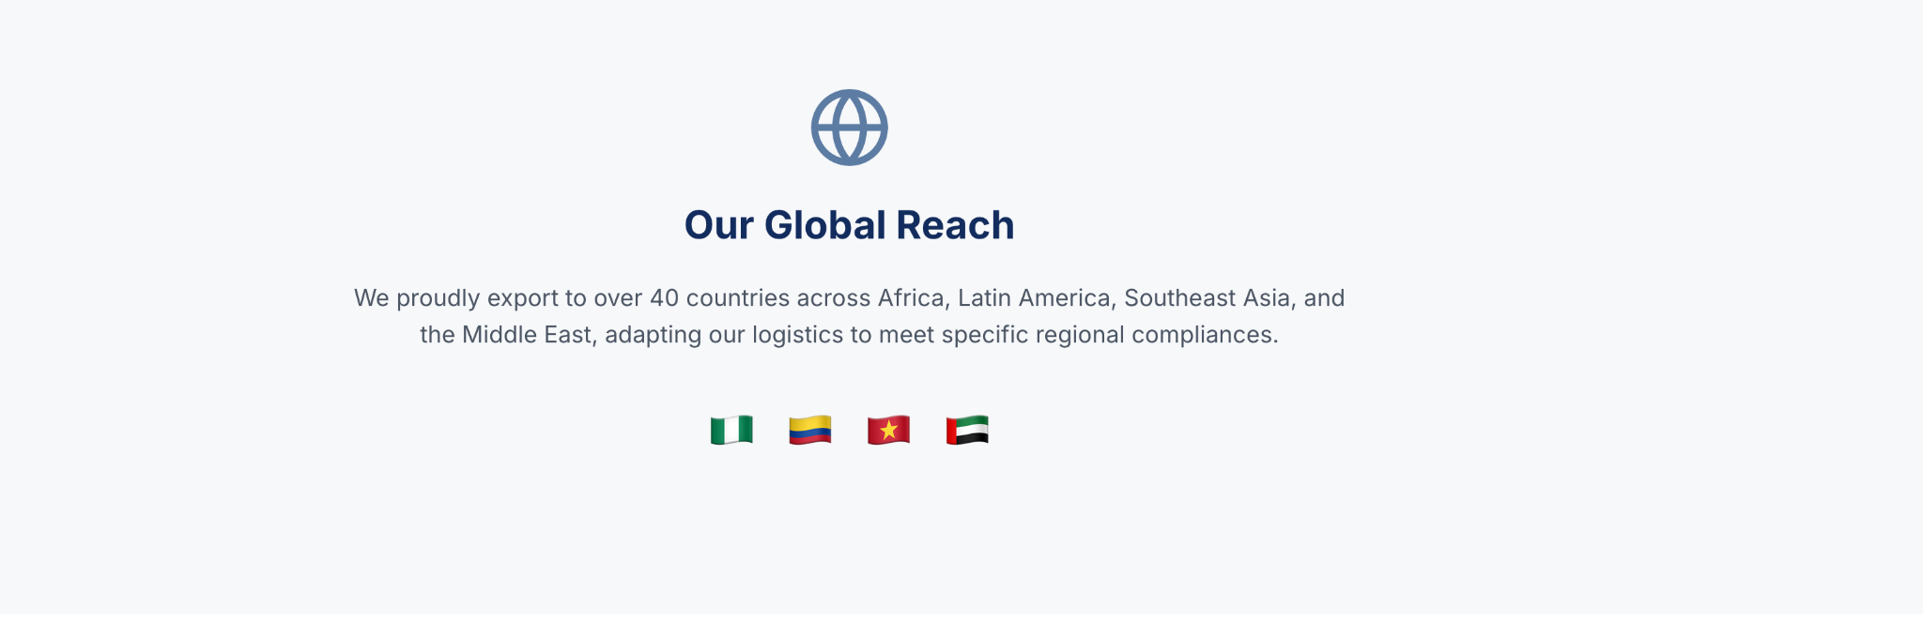

Connecting Businesses Across International Markets
As a trusted Wholesale Vehicle Exporter India, we supply vehicles and automotive products to businesses across global markets. From your enquiry to delivery, we're here to support you at every step.
Note to developer- make the moveable globe to match the aesthetics

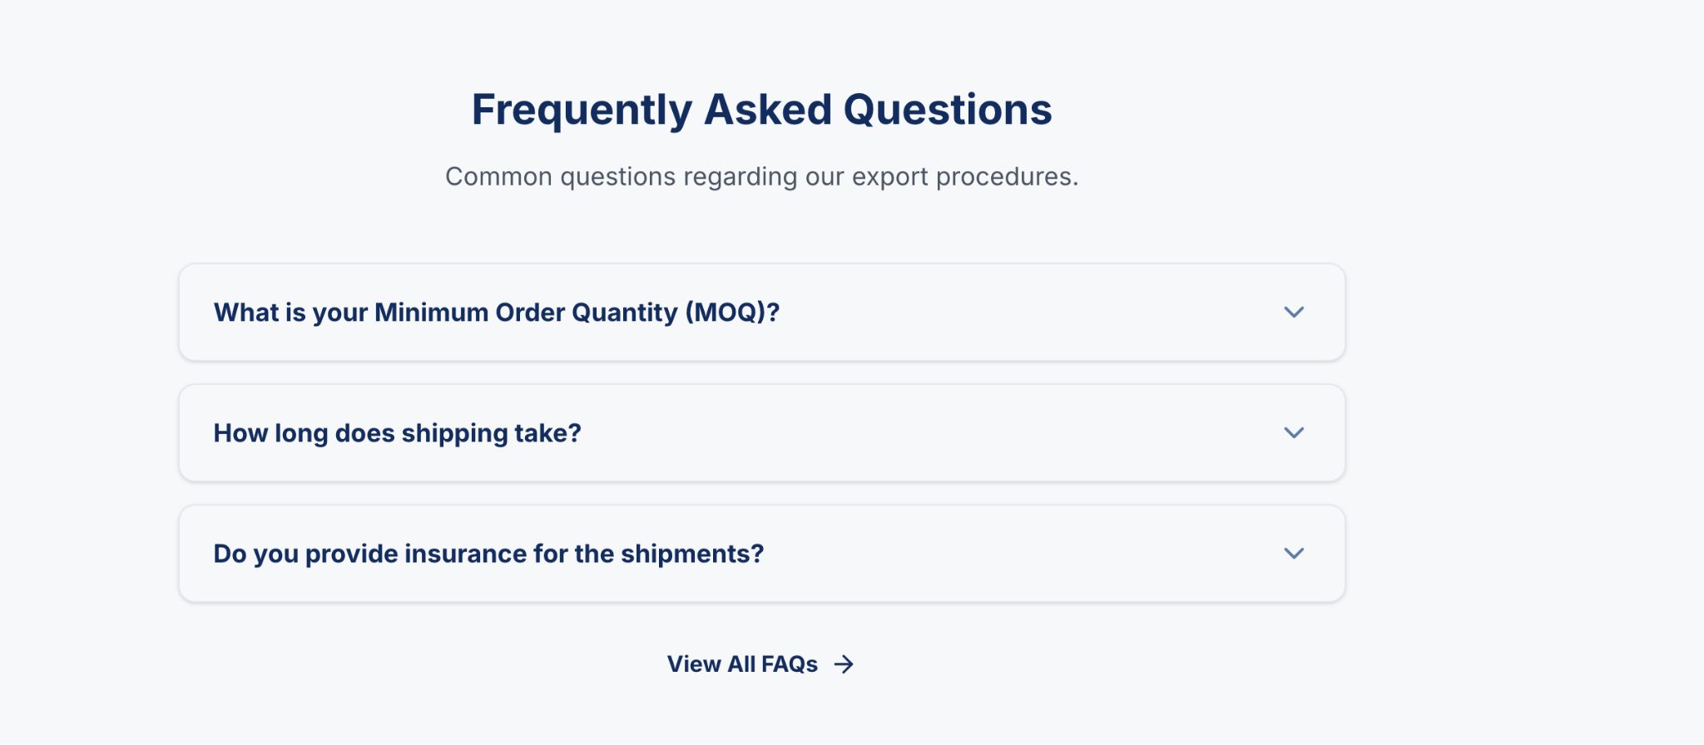

Frequently Asked Questions

Supporting Text
Find answers to common questions about our products, export process, and international supply.

What products do you export?
We export a wide range of vehicles, OEM spare parts, tyres, wheels, automotive accessories, and selected ceramic and wooden products for businesses across international markets.
Do you export two wheelers, three wheelers, and four wheelers?
Yes. We export a wide range of two wheelers, three wheelers, and four wheelers to businesses across international markets. As a trusted Automotive Export Company India, we help users to source quality vehicles that match their market requirements.

Do you assist with export documentation and shipping?
Yes. We assist with export documentation, shipping coordination, and the information required to help your order move smoothly from enquiry to delivery.
How do you ensure product quality?
Every product is carefully checked before shipping to make sure it meets our quality standards.
How do you ensure product quality?
Every product is checked before shipping to make sure it meets our quality standards.
How long does delivery take?
Delivery time depends on your destination country, order quantity, and shipping schedule. Once we receive your enquiry, we'll share an estimated delivery timeline.
How can I request a quotation?
Just send us the products you're looking for, the required quantity, and your destination country. We'll review your enquiry and get back to you with a quotation as soon as possible.

Note to developer - instead of view more faq make the button for send your query and interlink it to whatsapp



Request Your Export Quote
Looking for a trusted Automobile Exporter in India? Then share your product requirements, destination country, and required quantity, and our team will prepare a customized quotation with reliable export support from enquiry to delivery.
CTA: Request a Quote

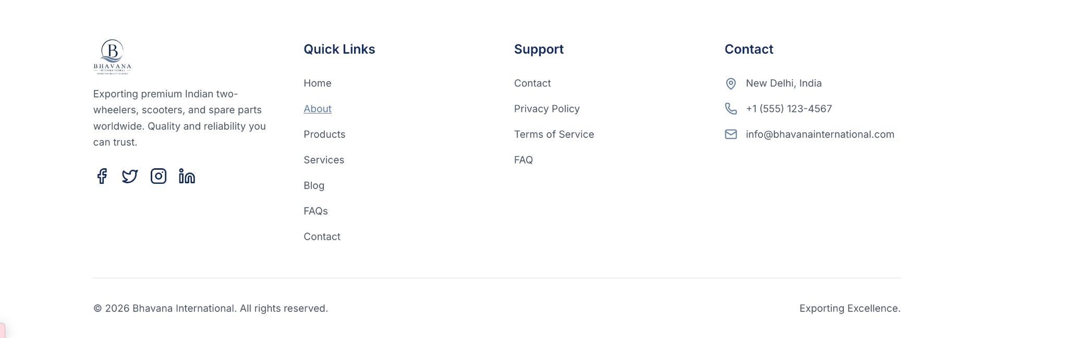

At Bhavana International, we help importers, distributors, and dealers source quality vehicles and automotive products from India. As a trusted Automobile Exporter in India, we're committed to making the export process simple and reliable.

Quick Links
- Home
- About Us
- What We Export
- Industries We Serve (only if this page exists)
- FAQs
- Contact Us (I recommend adding this)

Support
Only keep this section if these pages exist:
- Privacy Policy
- Terms & Conditions
Otherwise, remove the Support column entirely.

Contact
📍 New Delhi, India
📞 +91 96249 88888
📞 +91 98245 00234
✉️ info@bhavanainternational.com
( changes required here )
© 2026 Bhavana International. All Rights Reserved.

Bottom Tagline
Connecting India to the World

final about us

About Us
Primary Keyword
- Bhavana International
Secondary Keywords
- Automobile Export Company India
- Indian Vehicle Export Company
- Automotive Exporter India
- Global Automotive Supplier
- B2B Automobile Exporter

Meta Title
Bhavana International | Trusted Indian Vehicle Export Company
Meta Description
Learn about Bhavana International, a trusted Indian Vehicle Export Company supplying vehicles, OEM spare parts, and automotive products to businesses worldwide.



About Us
Learn more about Bhavana International, an Indian Vehicle Export Company helping businesses source vehicles and automotive products from India. We work with businesses across global markets and support you from enquiry to delivery.

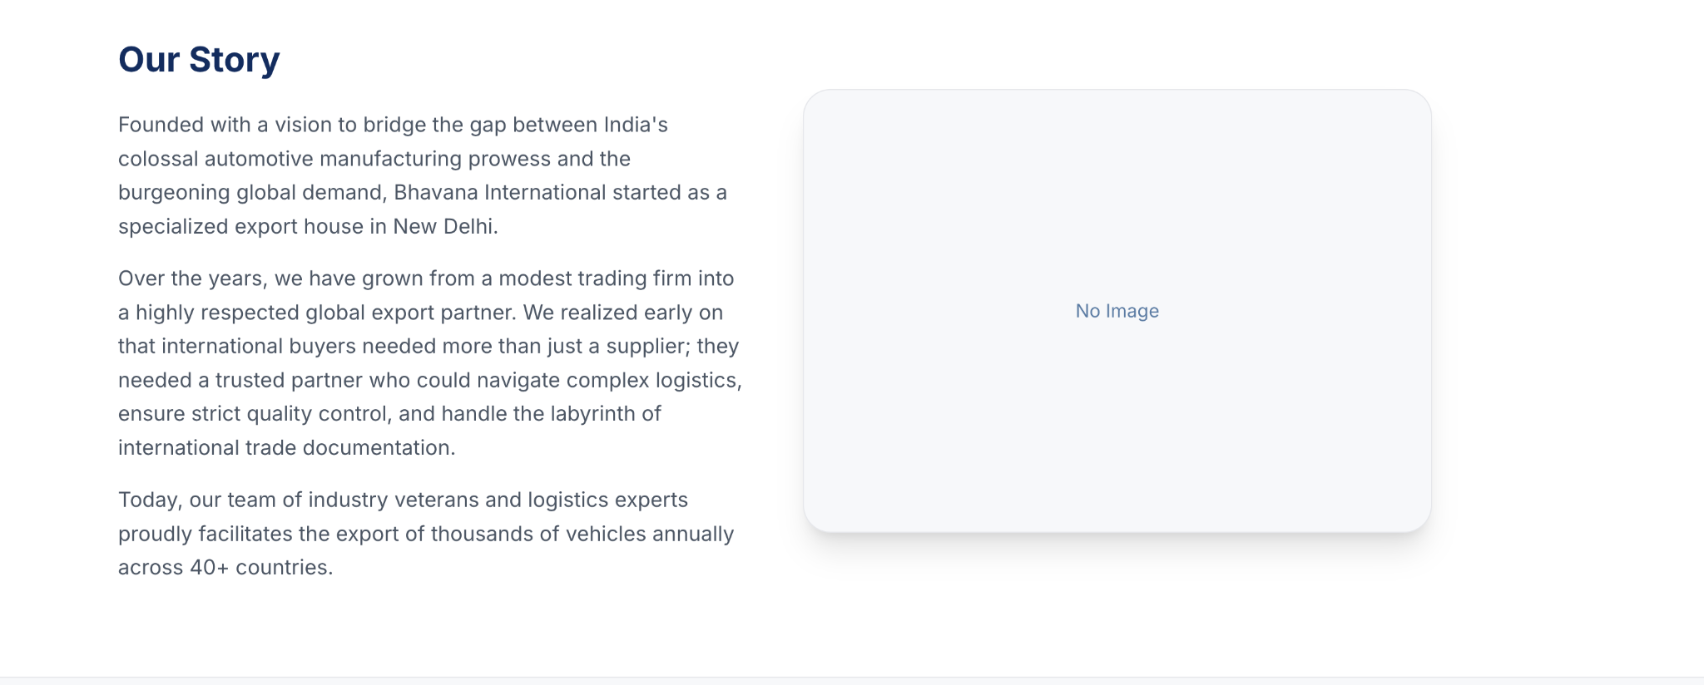

The Story Behind Bhavana International
Bhavana International was started to help businesses source quality vehicles and automotive products from India. Today, we work with businesses across global markets, helping them source quality vehicles and automotive products from India.
We take the time to understand your requirements before recommending the right products. From sourcing to delivery, we keep the process simple and keep you updated along the way.

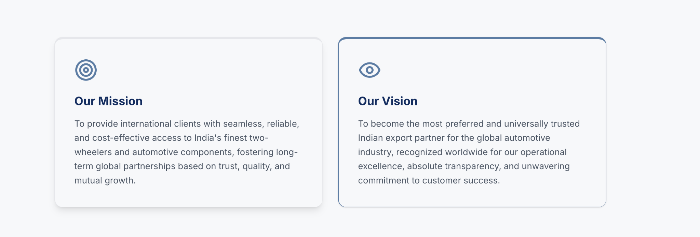

Our Mission
To help businesses around the world source quality vehicles and automotive products from India with reliable support, clear communication, and timely delivery.

Our Vision
To become a trusted Global Automotive Supplier, connecting businesses across international markets with quality products and dependable export services.

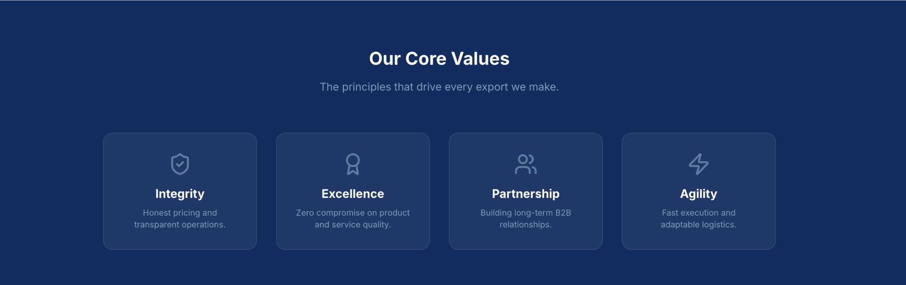

How We Work Together
Supporting Text
Every order starts with understanding your requirements. From there, we help with sourcing, documentation, and delivery while keeping you updated throughout the process.

Steps
Share Your Requirements
Tell us the products, quantity, and destination you need.
↓
Receive a Tailored Proposal
We recommend suitable products and provide a detailed quotation.
↓
Confirm Your Order
Once approved, we finalize the order and begin export preparation.
↓
Shipping & Export Coordination
We manage documentation and coordinate shipping for a smooth export process.
↓
Ongoing Support
Our team remains available to assist you before, during, and after delivery.

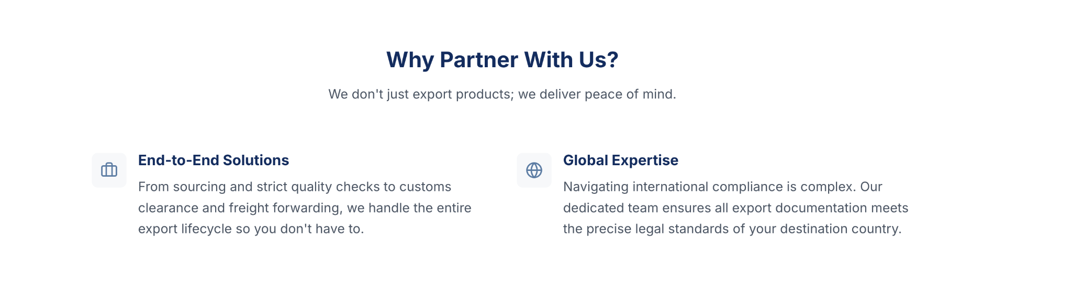

Why Choose Bhavana International?
Supporting Text

We combine quality products, reliable export solutions, and dedicated support to help your business grow.

Wide Product Portfolio

Source vehicles, OEM spare parts, tyres, wheels, automotive accessories, and selected products through one trusted export partner.

Quality You Can Trust

Every order is carefully inspected before shipment to help ensure it meets international quality standards.

Reliable Export Support

From product sourcing and documentation to shipping coordination, our team supports you throughout the export journey.

Long-Term Partnerships

We believe strong business relationships are built on transparency, responsive communication, and dependable service.



Ready to Partner with Bhavana International?
Supporting Text
Looking for a trusted B2B Automobile Exporter? Connect with our team to discuss your sourcing requirements and discover reliable export solutions tailored to your business.
CTA: Contact Our Team

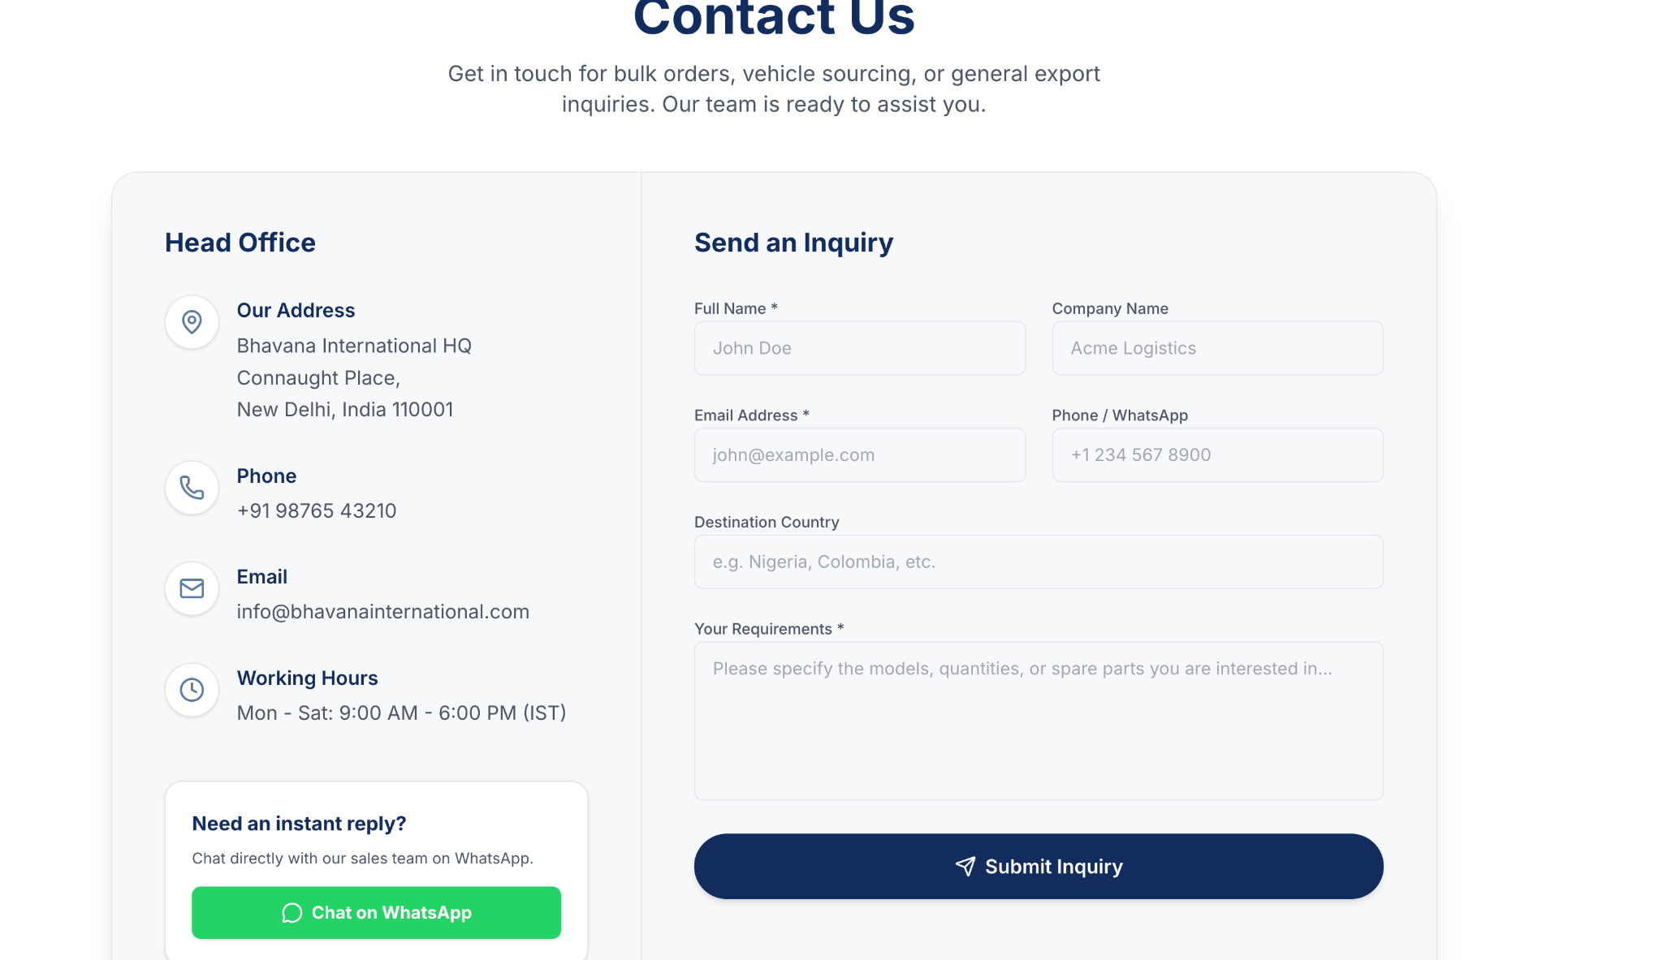

Let's Discuss Your Requirements

Supporting Text
Connect with Bhavana International, a trusted Automotive Exporter India, to discuss your sourcing requirements, product enquiries, and international export needs.

Head Office

Address
New Delhi, India

Phone
+91 96249 88888
+91 98245 00234

Email
info@bhavanainternational.com

Business Hours
Monday to Saturday
9:00 AM – 6:00 PM (IST)

WhatsApp Card

Need a Quick Response?
Connect with our team on WhatsApp for product enquiries, export assistance, and quick support.
CTA: Chat on WhatsApp

Right Side

Send an Inquiry
Form Fields
- Full Name*
- Company Name
- Email Address*
- Phone / WhatsApp Number*
- Country
- Interested In* (Dropdown)
Two Wheelers
Ev Two Wheelers
Three Wheelers
Four Wheelers
OEM Spare Parts
Tyres & Wheels
Automotive Accessories
Other
- Product Requirements*
- Message
Button: Send Inquiry
Message Placeholder
Tell us the products you're looking for, required quantity, destination country, or any specific requirements.

product page
Automotive Products Exporter India
Explore the wide range of automotive products exported by Bhavana International. As a trusted Automotive Products Exporter India, we supply quality two wheelers, three wheelers, four wheelers, OEM spare parts, tyres, wheels, and automotive accessories to importers, distributors, and dealers across global markets.

CTA Buttons
Primary CTA: Request a Quote
Secondary CTA: Contact Our Team
Explore Our Product Categories

Supporting Text
Discover our range of quality vehicles and automotive products, sourced from trusted manufacturers and supplied to businesses across global markets.

Product Category Cards
Two Wheelers
EV Two Wheeles
Three Wheelers
Four Wheelers
OEM Spare Parts
Tyres & Wheels
Automotive Accessories
Note to developer: Make each card clickable so it smoothly scrolls to its respective section further down the page. This keeps the design clean, premium, and easy to navigate while avoiding unnecessary text on the cards.
H2

Explore Our Automotive Product Range

Supporting Text
As a trusted Automotive Products Exporter India, Bhavana International offers a wide range of vehicles and automotive products sourced from reliable manufacturers. Explore our product categories designed to meet the needs of importers, distributors, and dealers across global markets.
🏍️ Two Wheelers
Source motorcycles and scooters from a trusted Two Wheeler Exporter India. We help businesses source quality vehicles from leading Indian manufacturers, offering options that suit different customer preferences and market requirements.
Motorcycles, Scooters,
Sports Bikes, Cruiser Bikes, Commuter Bikes
+ More
Request a Quote →
⚡ Electric Two Wheelers
Source innovative electric mobility solutions from a trusted Electric Two Wheeler Exporter India. We help businesses source reliable EV scooters and motorcycles designed to meet the growing demand for sustainable transportation across global markets.
Electric Scooters , Electric Motorcycles , High-Speed Models,
Low-Speed Models, Commercial Electric Vehicles + More
Request a Quote →

🛺 Three Wheelers
Our three-wheeler range supports commercial transportation and urban mobility across global markets. As a reliable Three Wheeler Exporter India, we supply vehicles built for passenger and cargo applications.
Passenger Carriers Cargo, Carriers Electric Three Wheelers,
Commercial Vehicles, Utility Vehicles
+ More
Request a Quote →

🚗 Four Wheelers
Explore passenger and commercial vehicles sourced from trusted Indian manufacturers. As an experienced Four Wheeler Exporter India, we help businesses find reliable petrol and elertic vehicles for a variety of market needs.
Hatchbacks, Sedans, SUVs,
Pickup Trucks, Commercial Vehicles, Electric Vehicles,
+ More
Request a Quote →

⚙️ OEM Spare Parts
We supply genuine components as a trusted OEM Spare Parts Exporter India and Vehicle Spare Parts Supplier India, helping businesses source reliable parts for different vehicle categories.
Engine Parts Brake Parts Electrical Parts
Suspension Parts Filters Body Parts
+ More
Request a Quote →

🛞 Tyres & Wheels
Built for performance and durability, our tyre and wheel range supports passenger and commercial vehicles. We are a trusted Tyre & Wheel Exporter India serving businesses across international markets.
Passenger Tyres, Commercial Tyres, Alloy Wheels,
Steel Wheels, Wheel Accessories, Tubes
+ More
Request a Quote →

🚘 Automotive Accessories
From everyday essentials to premium upgrades, we supply quality products as an experienced Auto Accessories Exporter India, helping businesses meet diverse customer requirements.
Interior Accessories, Exterior Accessories, Lighting
Safety, Accessories, Car Care Products, Electronics
+ More
Request a Quote →

Every Product, Sourced with Confidence
Supporting Text
Every product is carefully sourced to deliver quality, reliability, and a seamless export experience.

Card 1
Trusted Sourcing
Products sourced from reliable manufacturers across India.

Card 2
Quality Assured
Every product is inspected before shipment.

Card 3
Export Ready
Complete support for documentation and shipping.

Card 4
Dedicated Support
Responsive assistance from enquiry to delivery.
Brands
│
FAQs
│
CTA
│
Footer

Tab 5
Hero
│
Product Categories (Cards)
│
──────────────
Two Wheelers
──────────────
Three Wheelers
──────────────
Four Wheelers
──────────────
OEM Spare Parts
──────────────
Tyres & Wheels
──────────────
Automotive Accessories
│
Why Source From Us
│
Brands
│
FAQs
│
CTA
│
Footer

